* Results
- what was achieved
- what could not be achieved.

Motivation
Air traffic control (ATC) is a service provided by ground-based air traffic controllers who direct aircraft on the ground and through a section of controlled airspace as well as providing advising services to aircraft flying in non-controlled airspace. Since the early 1920s, ATC has been an important aspect of the aviation business. It was initially designed for military aircraft, but as passenger and freight flights became more common, air traffic rose, and ATC evolved into its modern form. The air traffic control system's day-to-day issues are mostly tied to the amount of air traffic demand placed on the system and the weather. The volume of traffic that may land at an airport in a given amount of time is determined by several factors.

Airplanes travel along established routes called airways, even though they are not physical constructions. They are defined by a particular width and altitudes, which separate air traffic moving in opposite directions along the same airway. Unlike on highways in which a collision threat is nearly always apparent, here a pilot is much more concerned with monitoring aircraft status than looking around for nearby planes.

Air traffic controllers use radar to track planes in their allotted airspace and communicate with pilots through radio. ATC enforces traffic separation standards to prevent collisions by ensuring that each aircraft has a minimum amount of empty space around it at all times. Air traffic control errors occur when the separation (either vertical or horizontal) between airborne aircraft falls below the minimum prescribed separation set by the US Federal Aviation Administration (FAA). The primary purpose of ATC is to prevent collisions, organize and expedite the flow of air traffic, etc. between origin and destination airports. The pilot in command has final authority over the aircraft's safe operation and may, in an emergency, divert from ATC directives to the extent necessary to keep their aircraft safe.

In 1981, the FAA developed TCAS (Traffic Alert and Collision Avoidance System), a mid-air collision avoidance system in response to rising aviation traffic and incidents of mid-air collisions. A new system called ACAS-Xu (Airborne Collision Avoidance System) is currently being developed which utilizes advancements in computer science and dynamic programming to generate alerts.[1].

Problem Statement

A critical component of ATC is the task of directing airplanes to take-off and land between origin and destination airports without collisions. It's a difficult task that necessitates a series of difficult judgments. We describe a method for training an agent to autonomously direct flights to their destinations without colliding, in a 2D version of ATC. The problem is framed as a Markov decision process, and the SARSA reinforcement learning algorithm is used to control the planes' trajectories so that they arrive at their desired destinations without colliding. Our environment contains uncertainties in the form of spawn location fluctuation, plane number, plane starting heading direction, and unknown destinations.

Our general approach is to send planes on straight-line trajectories towards their destinations, with an ACAS-like, SARSA-based agent that takes over when two planes are in danger of collision.

Methodology
- ENVIRONMENT
Each plane begins with a straight-line trajectory to its destination airport but has the ability for waypoints to be added along that trajectory to ensure that no planes collide into other planes or static objects. The goal of the game is to ensure that all planes can reach their destination without any collisions.

- MDP MODEL
MDP Architecture
Similar to the ACAS/TCAS system, our task is to generate the optimal policy that a plane could follow to avoid a collision
with an intruder aircraft nearby. The MDP formulation for SARSA requires a definition of the state space, action space, and reward model, which we will describe next.

STATE Space
Our state space formulation is inspired by the ACAS-Xu system and measurements, real aircraft might receive about other nearby aircraft. We obtain these ‘measurements’ in real time and update the agent’s states accordingly.
We have discretized the measurements into buckets to reduce the size of our state space and compress the look-up table. The angle to intruder and relative heading of intruder are each 36 buckets of 10-degree intervals, representing the full 360 degrees. The distance to the intruder is measured in pixels, where 50 is the threshold radius for deploying the agent. The full size of our state space is 64,800, which is a compact representation compared to the 120 million states needed for ACAS-Xu.
Table1 describes our state space.

State variable | Description | No. of elements
d | Distance to intruder | 50
ρ | Angle to intruder | 36
θ | Relative heading of intruder | 36

TABLE I: STATE Space

ACTION Space
We have chosen to limit our action space to 5. Our action space consists of going straight (N), taking a medium turn (ML, MR), or taking a hard turn (HL, HR). In pixel space, N corresponds to setting the next direction vector of the aircraft to the top centre pixel. In a similar fashion, ML and MR correspond to the top left and top right pixels, while HL and HR correspond to the left centre and right centre pixels. Table2 describes our actions.

Action | Description
N | Maintain course
HL | Hard left
ML | Medium Left
MR | Medium Right
HR | Hard Right

TABLE I: ACTION Space

REWARD Model

Our reward model is dependent on the state variables. We decided to focus on two components, distance and destination.

For distance, we want the negative reward to increase quadratically as intruder planes became closer to our own ship. This means our algorithm would be less likely to choose actions that resulted in a decrease of distance between any two planes. Equation (1) describes the function used.

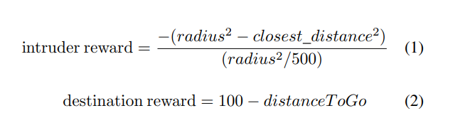

where, radius is the threshold distance of 50 for deploying the agent and closest_distance is the distance between any plane and the plane it is closest to. By using the scaling factor in the denominator, it allows us to vary the negative reward from 0 when the planes are 50 pixels away, to 500 when the planes are about to collide.

We also chose to create a positive reward for reaching a destination so that the agent would be motivated to route the plane to a destination despite a nearby intruder. To handle this, we created a function called getDistanceToGo()
that calculated the distance from the current ship to its destination. Equation (2) describes our reward for approaching a destination. In the below equation, distanceToGo is the result of getDistanceToGo().

Both rewards are distributed to all agents per timestep in the update function of our learning algorithm. Additionally, to account for planes that have already reached the destination, we propagate the reward of reaching the terminal state back throughout the look-up table.

But in the research paper it’s not clear how the authors integrated these 2 rewards into the SARSA Algorithm. Since SARSA only takes one reward in each timestep. Due to this ambiguity, we used a reward function as described below:
Total Reward = intruder reward + destination reward

Total Reward range = [-500,100]
If closest_distance > 50, then intruder reward = 0
With this our reward takes both the rewards into account. And motivates the agent to get maximum reward i.e., try to avoid collisions but also avoid in such a way which maximizes the destination reward.

IMPLEMENTATION

However, in this project, we are only focusing on avoiding collisions and could not predict which actions would lead to collisions and which ones would not We chose a model-free learning technique utilising Temporal Difference because we wanted our agent (planes) to learn how to avoid collisions from actual experience rather than an unknown collision model (TD). Temporal Difference algorithms allow an agent to learn via each action it performs by updating the agent's knowledge at each time step rather than at the end of each episode (achieving the goal/end state). This knowledge update is the update of the estimate of the utility given by:

New = Old + α (Target - Old) ------- (3)

Here the new estimate is proportional to the difference in target utility and the previous estimate. α in the above equation
is called the learning rate and is representative of the step size applied in the update with values between 0 and 1.

SARSA

We chose SARSA as our reinforcement learning algorithm as SARSA uses the actual action taken at st+1 to update Q values instead of maximizing over all possible actions as done in Q-learning. SARSA is an on-policy learning algorithm, meaning it learns the value of the policy being carried out by the agent, including the exploration steps, while the policy continues to be followed.

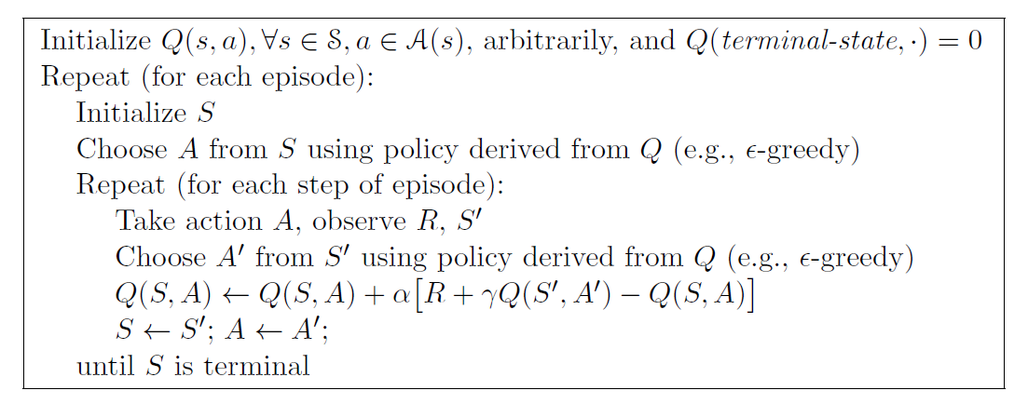

SARSA Implementation

We implemented our MDP structure as a class in Python. Below points describe how this algorithm helps to train
our agents to avoid collision between each other:
- We initialize the Q table with zero.
- The first episode starts alongside the start of the game with multiple planes spawning in random locations heading towards a destination airport (each episode represents one instance of training without collision).
- We save an offline policy look-up table (Q table) after simulation of every 25 episodes which may be used later.
- We choose an action based on an already trained Q-table saved previously.
- We run the game in timesteps permitted by the environment.
- We train our MDP for planes which are within the collision radius and choose an action (turning in a particular direction) using an exploration vs. exploitation strategy.
- We observe the next state and reward gained after taking the previous action and ending up in the next state.
- Based on the previous action, state and reward we update our Q - values.
- Finally, we update the state and action of the planes
- We repeat this until the planes reach their destination (goal state) or until there is a collision.
- We train the model until the desired number of episodes, and the learned policy can be saved in the form of a Qtable.

Simulation Configuration

We have modified our simulation environment such that it can accept various parameters. Following are the
parameters, which can be varied during training:
- number of planes
- number of spawnpoints
- number of destinations
- number of obstacles
- load a previously trained Q-table
- learning rate
- discount factor
- exploration probability

RESULTS

To measure the performance of our RL agent, we simulated our game environment with the following parameters: one airport destination, no obstacles, 25 planes, and a varying number of episodes. Each episode is a run of the program where the agent accumulates points until two planes collided. We trained our SARSA agent with 25 planes to follow a single airport destination. A learning rate of 0.5 and a discount factor of 0.9. In this case, we started with an exploration probability of 0.5; which we reduced by 10% every 10 episodes. The reason for doing this is that we wanted to start with more exploration and gradually reduce the exploration to start exploiting the knowledge gained from our Q-Tables. As you can see in Fig. 5, our SARSA agent has an average score of around 300,

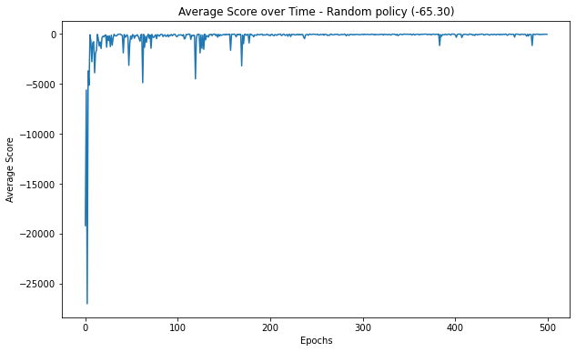

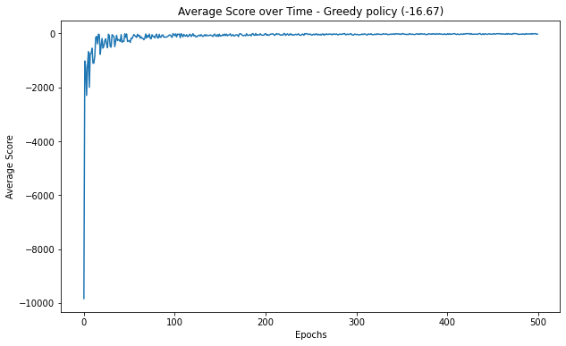

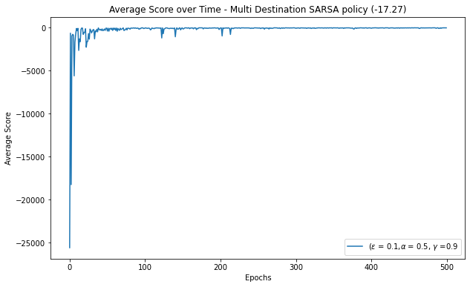

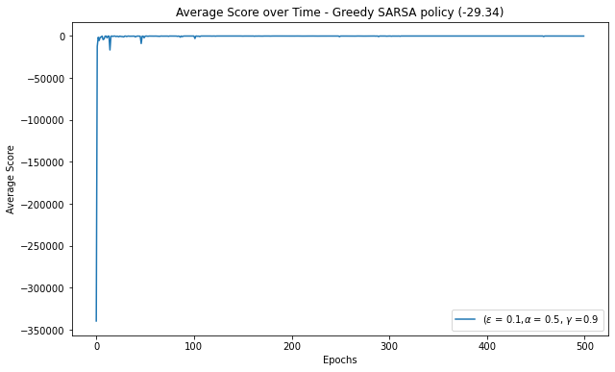

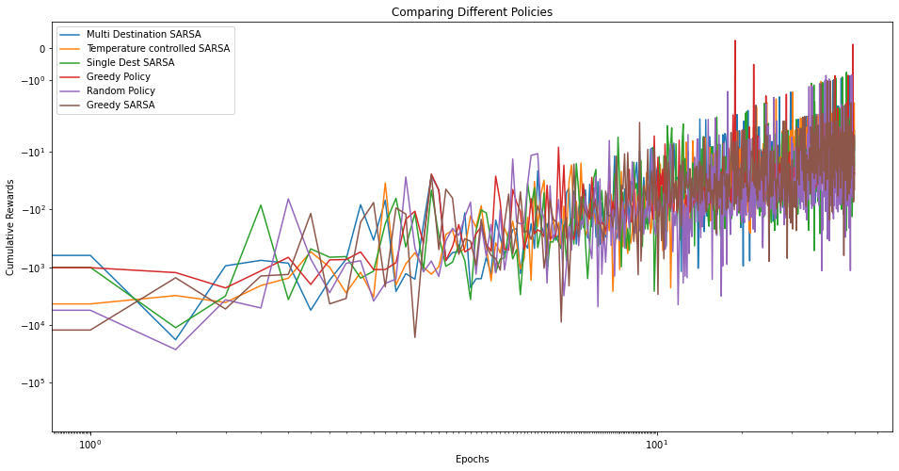

Conclusion

Our SARSA agent was able to achieve reasonable success in collision avoidance compared to our baseline agents. Our RL agent had consistently better scores once it had learned from its initial episodes.

The authors suggested to implement the SARSA with different obstacles and multiple airport destinations
with often crossing paths. And we were successfully able to implement that with our environment thanks to our custom environment code, which we wrote from the ground-up. In our environment we can select how many destinations we would like to have. It can range from 1, where all the planes land at same destination (same as implemented in the paper), to number of planes, where each plane lands at a different destination.

Limitations

Because of time and computational constraints, there still remains a lot of room for improvement and development for our agent. We can add actions to our agents such as an option to reduce or increase the speed along with an option to change directions.

We can also use Deep Neural Network methods for reinforcement learning to check performs of our aircraft collision avoidance model. Another extension for our project could be to model our agent using a POMDP approach instead of an MDP by introducing state uncertainty along with noisy measurements.

We could also try other RL algorithms instead of SARSA.

